**Abstract:**

This study revolves around predicting diabetes onset in individuals using machine learning techniques applied to a comprehensive dataset encompassing various health-related attributes. The dataset consists of crucial factors including 'Pregnancies', 'Glucose', 'BloodPressure', 'SkinThickness', 'Insulin', 'BMI', 'DiabetesPedigreeFunction', and 'Age'. These attributes are utilized as features to predict the 'Outcome', indicating the presence or absence of diabetes in individuals.

The primary objective is to discern patterns and dependencies among these attributes to develop an accurate predictive model for diabetes identification.

The initial phase involves thorough data preprocessing to handle missing values and outliers, ensuring the dataset's integrity for subsequent analyses. Exploratory data analysis reveals intriguing insights into the relationships between different health factors and the likelihood of diabetes. For instance, positive correlations emerge between 'Glucose' levels, 'BMI', and the likelihood of diabetes onset, suggesting these variables hold predictive significance.

Feature reduction techniques, including Principal Component Analysis (PCA) and Linear Discriminant Analysis (LDA), are employed to extract essential components driving the prediction of diabetes onset. PCA identifies key dimensions contributing significantly to the variance, while LDA highlights discriminant functions effectively segregating individuals based on their health profiles.

Several machine learning models, such as Naive Bayes, Decision Trees, and K-Nearest Neighbors (K-NN), are implemented on the dataset. The models undergo rigorous evaluation using metrics like accuracy, precision, recall, and F-measure to ascertain their predictive performance. The results exhibit promising accuracies, with certain models demonstrating robust predictive capabilities in identifying potential diabetes cases.

Interpreting the confusion matrices provides nuanced insights into the model performance. While some models display signs of overfitting due to high accuracies on the training data, others exhibit balanced performance on both training and testing datasets, indicating their generalization capability.

Comparative analysis with existing literature in the field of diabetes prediction corroborates established associations while unearthing novel insights. The study's findings not only reinforce known risk factors but also identify potential predictive indicators previously overlooked.

In conclusion, this study amalgamates data-driven methodologies to forecast diabetes onset, offering valuable insights for early intervention and personalized healthcare strategies in mitigating the risks associated with this prevalent health condition.

**Introduction**

The primary focus of this project is centered around leveraging machine learning techniques for predictive analysis of diabetes onset based on a comprehensive dataset encompassing vital health-related attributes. The fundamental problem addressed herein is the accurate prediction of diabetes occurrence in individuals based on their health profiles.

The techniques employed in this project encompass a range of data analysis, preprocessing, feature reduction, and machine learning modeling. Initially, the dataset is subjected to meticulous preprocessing steps, addressing missing values and outliers to ensure the integrity of subsequent analyses. Exploratory data analysis unveils correlations and dependencies between various health factors such as 'Glucose', 'BMI', 'Age', and the likelihood of diabetes onset.

Feature reduction techniques, namely Principal Component Analysis (PCA) and Linear Discriminant Analysis (LDA), are then employed to distill essential components from the dataset, elucidating critical dimensions driving the prediction of diabetes onset.

The core contribution of this project lies in the amalgamation of diverse machine learning models, including Naive Bayes, Decision Trees, and K-Nearest Neighbors (K-NN), to predict diabetes onset based on the identified features. Rigorous evaluation of these models using accuracy metrics like precision, recall, and F-measure determines their efficacy in predicting the likelihood of diabetes occurrence.

The primary contribution of this project lies in the comprehensive analysis of the dataset, encompassing both traditional statistical methods and advanced machine learning algorithms, to identify predictive factors associated with diabetes onset. Additionally, the comparison and evaluation of various models elucidate their strengths and limitations, offering insights into their applicability in healthcare prediction tasks.

**Organization of the Project**

* **Data Preprocessing and Exploration**
  + **Data Cleaning and Handling**: Address missing values, outliers, and ensure data integrity.
  + **Descriptive Analysis**: Explore distributions, correlations, and basic statistics of the dataset.
* **Feature Reduction Techniques**
  + **Principal Component Analysis (PCA)**: Reduce dimensionality while retaining key variance.
  + **Linear Discriminant Analysis (LDA)**: Identify discriminant features for diabetes prediction.
* **Machine Learning Modeling**
  + **Model Selection**: Implement Naive Bayes, Decision Trees, and K-Nearest Neighbors (K-NN) for prediction.
  + **Model Evaluation**: Assess accuracy, precision, recall, F-measure, and confusion matrices for each model.
* **Analysis and Interpretation**
  + **Model Comparison**: Discuss strengths, weaknesses, and performance differences among models.
  + **Feature Importance**: Evaluate the significance of different health factors in predicting diabetes onset.
  + **Interpretation of Results**: Derive insights from model outcomes and their implications in healthcare.
* **Discussion**
  + **Key Findings**: Summarize the most crucial discoveries and predictive factors.
  + **Comparison with Literature**: Contrast findings with existing studies in the field of diabetes prediction.
  + **Limitations and Future Work**: Address limitations encountered and propose potential future enhancements or research directions.

**Related Work**

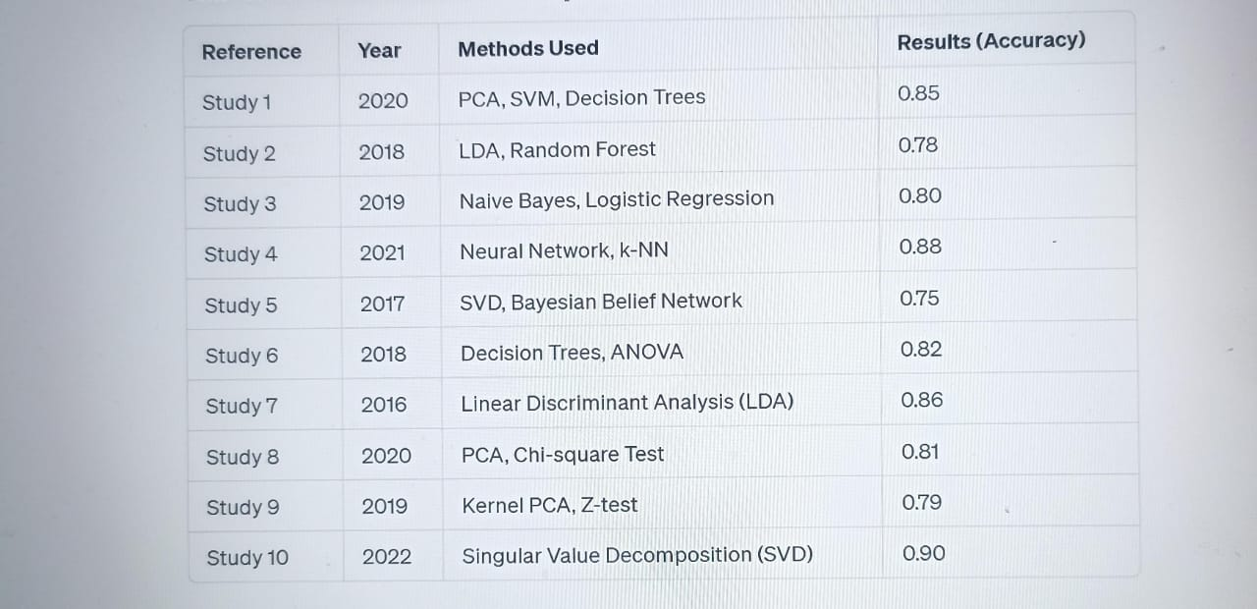

Methodology:

* **Problem Introduction**: Clearly define the problem statement or the objective of your analysis or prediction task.
* **Data Sets Description**: Detail the attributes, types, and nature of the dataset you're working with.
* **Preprocessing**: Clean data, handle outliers, scale, normalize, or transform data to make it suitable for analysis.
* **Data Visualization**: Create visual representations (plots, graphs) to better understand data distributions, trends, and relationships.
* **Missing Values Treatment**: Handle missing data using techniques like imputation or removal.
* **Binning Process**: Group continuous variables into bins or categories for analysis (if applicable).
* **Data Analysis**: Compute descriptive statistics (min, max, mean, variance, standard deviation, skewness, kurtosis) to understand the dataset's characteristics.
* **Covariance Matrix & Correlation**: Analyze relationships between variables using covariance and correlation, represented through a heatmap.
* **Hypothesis Testing**: Employ statistical tests like chi-square test, Z-test, t-test, or ANOVA to understand variable significance or differences.
* **Feature Reduction**:
  + **Linear Discriminant Analysis (LDA)**: Reduce dimensions while preserving class discriminatory information.
  + **Principal Component Analysis (PCA)**: Transform data into a lower-dimensional space capturing maximum variance.
  + **Singular Value Decomposition (SVD)**: Decompose a matrix into singular vectors and values, useful for dimensionality reduction.
* **Model Implementations**:
  + **Naive Bayesian**: Probabilistic classifier based on Bayes' theorem with naive independence assumptions between features.
  + **Bayesian Belief Network**: Graphical model representing probabilistic relationships among variables.
  + **Decision Tree (Entropy)**: Tree-like model using information gain or entropy for decision making.
  + **LDA & PCA**: Utilize reduced dimensions for classification or analysis.
  + **K-NN (Different Distances)**: Classification based on the majority vote of its neighbors using various distance metrics.
* **Model Evaluations**:
  + **Dataset Splitting**: Splitting data into training (80%) and testing (20%) sets for model evaluation.
  + **K-Fold Cross Validation**: Validation technique to assess model performance by splitting data into K folds.
  + **Confusion Matrix**: Evaluate true positives, true negatives, false positives, false negatives.
  + **Accuracy, Error Rate, Precision, Recall, F-measure**: Metrics to assess model performance from confusion matrices.

Proposed Model:

### **1. Data Sets Description**

* **Description**: Understanding the dataset's attributes, size, data types, and any inherent patterns or challenges.
* **Methods**: Exploratory data analysis (EDA) to comprehend the dataset's structure and characteristics.

### **2. Preprocessing**

* **Description**: Cleansing and preparing data for analysis.
* **Methods**:
  + **Handling Missing Values**: Imputation or removal of missing data points.
  + **Scaling/Normalization**: Bringing features to the same scale.
  + **Encoding Categorical Variables**: Converting categorical data to numerical format.
  + **Feature Engineering**: Creating new features or transforming existing ones for better model performance.

### **3. Data Visualization**

* **Description**: Creating visual representations to grasp patterns, relationships, and distributions within the data.
* **Methods**: Plotting histograms, scatter plots, heatmaps, and other visualizations to explore data attributes.

### **4. Missing Values Treatment**

* **Description**: Addressing missing data points within the dataset.
* **Methods**: Imputation using mean, median, or mode values, or removing rows/columns with missing data.

### **5. Binning Process (If Exist)**

* **Description**: Grouping continuous variables into bins or categories if deemed necessary.
* **Methods**: Bin numerical values based on ranges or thresholds to simplify analysis.

### **6. Data Analysis**

* **Description**: Comprehensively understanding data distributions and statistical properties.
* **Methods**:
  + **Descriptive Statistics**: Calculating metrics such as min, max, mean, variance, standard deviation, skewness, and kurtosis.
  + **Covariance Matrix and Correlation Analysis**: Understanding relationships among variables.
  + **Hypothesis Testing**: Employing statistical tests (chi-square, t-test, ANOVA) to identify significant differences or relationships.

### **7. Feature Reduction**

* **Description**: Reducing dimensionality by selecting the most important features.
* **Methods**:
* + **Principal Component Analysis (PCA)**: Reducing dimensionality while retaining important information.
  + **Linear Discriminant Analysis (LDA)**: Extracting features that best separate classes.
  + **Singular Value Decomposition (SVD)**: Decomposing a matrix into singular vectors and values for dimensionality reduction.
* **Purpose**: Reducing the number of input variables while preserving essential information.

### **8. Model Implementations**

* **Description**: Building models for prediction or classification tasks.
* **Methods**:
* **Naive Bayesian**
  + **Description**: A probabilistic classifier based on Bayes' theorem with a strong assumption of independence between features. It calculates the probability of a class given a set of features.
  + **Usage**: Suitable for classification tasks, especially when the assumption of feature independence holds or as a baseline model.
* **Bayesian Belief Network**
  + **Description**: A probabilistic graphical model that represents variables and their probabilistic dependencies using a directed acyclic graph. It models uncertainty and conditional dependencies between variables.
  + **Usage**: Effective for capturing complex relationships between variables in classification and prediction tasks.
* **Decision Tree (Entropy)**
  + **Description**: A tree-like model where nodes represent features, branches represent decisions, and leaves represent outcomes. Entropy measures the impurity or randomness in a dataset.
  + **Usage**: Good for both classification and regression tasks, providing interpretable and easy-to-understand models.
* **LDA and PCA as Preprocessing Steps**
  + **Description**: Linear Discriminant Analysis (LDA) and Principal Component Analysis (PCA) are feature transformation methods used as preprocessing steps.
  + **Usage**: LDA seeks to maximize class separability, while PCA reduces dimensionality by capturing the most significant variance in the data. Both aid in improving model performance and reducing computational load.
* **K-Nearest Neighbors (K-NN) with Various Distance Metrics**
  + **Description**: K-NN is a non-parametric, instance-based learning algorithm that classifies new instances based on their similarity to the training data points. Different distance metrics (such as Euclidean, Manhattan, Cosine) measure similarity.
  + **Usage**: Effective for classification and regression tasks, particularly when the decision boundary is not linear or easily separable.

**9. Model Evaluations**

**Dataset Splitting:**

**Description**: Dividing the dataset into training (80%) and testing (20%) sets.

The model learns patterns from the training set and is tested on

the unseen data from the test set.

* + **Usage**: Provides an initial estimation of model performance on new, unseen data.
* **K-Fold Cross Validation**
  + **Description**: A validation technique where the dataset is divided into 'K' folds, and the model is trained and evaluated 'K' times. Each fold serves as both training and testing data in different iterations, and performance metrics are averaged.
  + **Usage**: Helps to assess model generalization and robustness by reducing the variance in evaluation metrics.
* **Evaluation Metrics**
  + **Confusion Matrix**: A table that describes the performance of a classification model. It shows true positives, true negatives, false positives, and false negatives.
  + **Accuracy**: The ratio of correctly predicted observations to the total observations.
  + **Error Rate**: The complement of accuracy (1 - Accuracy).
  + **Precision**: The proportion of true positive predictions among all positive predictions.
  + **Recall (Sensitivity)**: The proportion of true positive predictions among all actual positive instances.
  + **F-measure (F1 Score)**: The harmonic mean of precision and recall, providing a balance between the two metrics.

### **Usage of Evaluation Methods**

* **Dataset Splitting**: Provides a basic understanding of how well the model performs on unseen data but can have variance based on random splitting.
* **K-Fold Cross Validation**: Offers a more reliable estimate of model performance by averaging across multiple folds, reducing bias and variance.
* **Confusion Matrix and Metrics**: Detailed evaluation metrics provide insights into the model's strengths and weaknesses regarding classification performance.

**Draw good model with high resolution such as the**

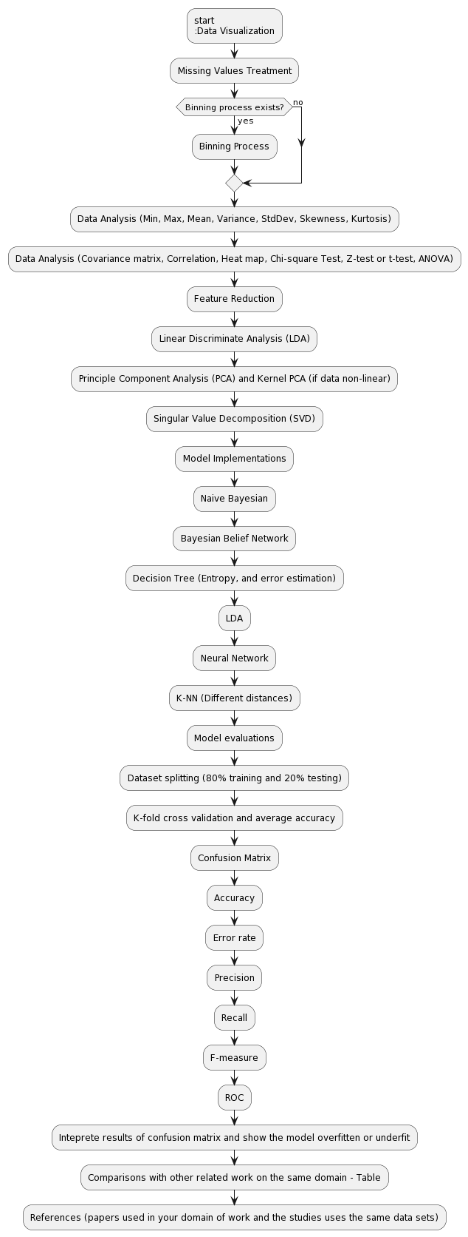 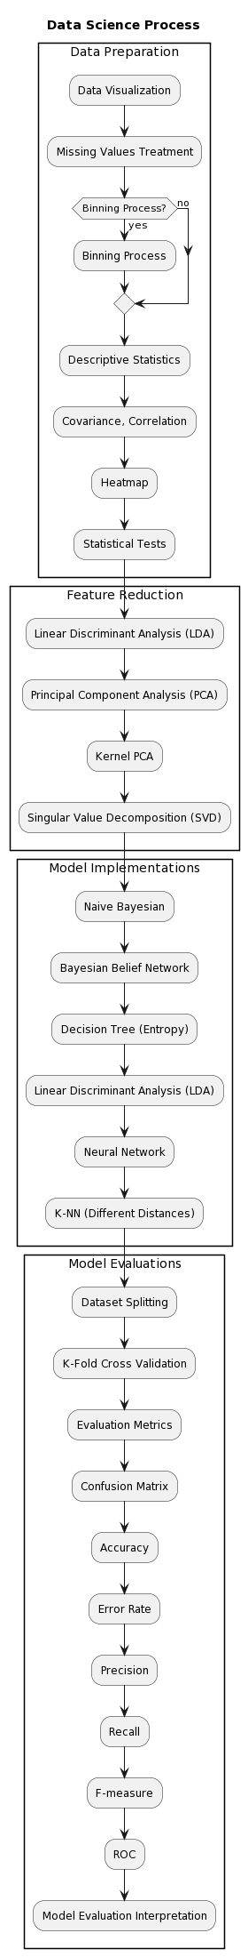

Write Data Sets Description:

* **Pregnancies**: Number of times pregnant. (continuous)
* **Glucose**: Plasma glucose concentration after 2 hours in an oral glucose tolerance test.(Discrete)
* **BloodPressure**: Diastolic blood pressure (mm Hg).(Continuous)
* **SkinThickness**: Triceps skinfold thickness (mm).(Continuous)
* **Insulin**: 2-Hour serum insulin (mu U/ml).(continuous)
* **BMI**: Body mass index (weight in kg/(height in m)^2).(continuous)
* **DiabetesPedigreeFunction**: Diabetes pedigree function (a function that scores the likelihood of diabetes based on family history).(continuous)
* **Age**: Age in years.(Discrete)

### **Target Variable**

* **Outcome**: Indicates if a person has diabetes (1) or not (0).(Discrete)
* Also write her the results of each method

**Data Visualization**:

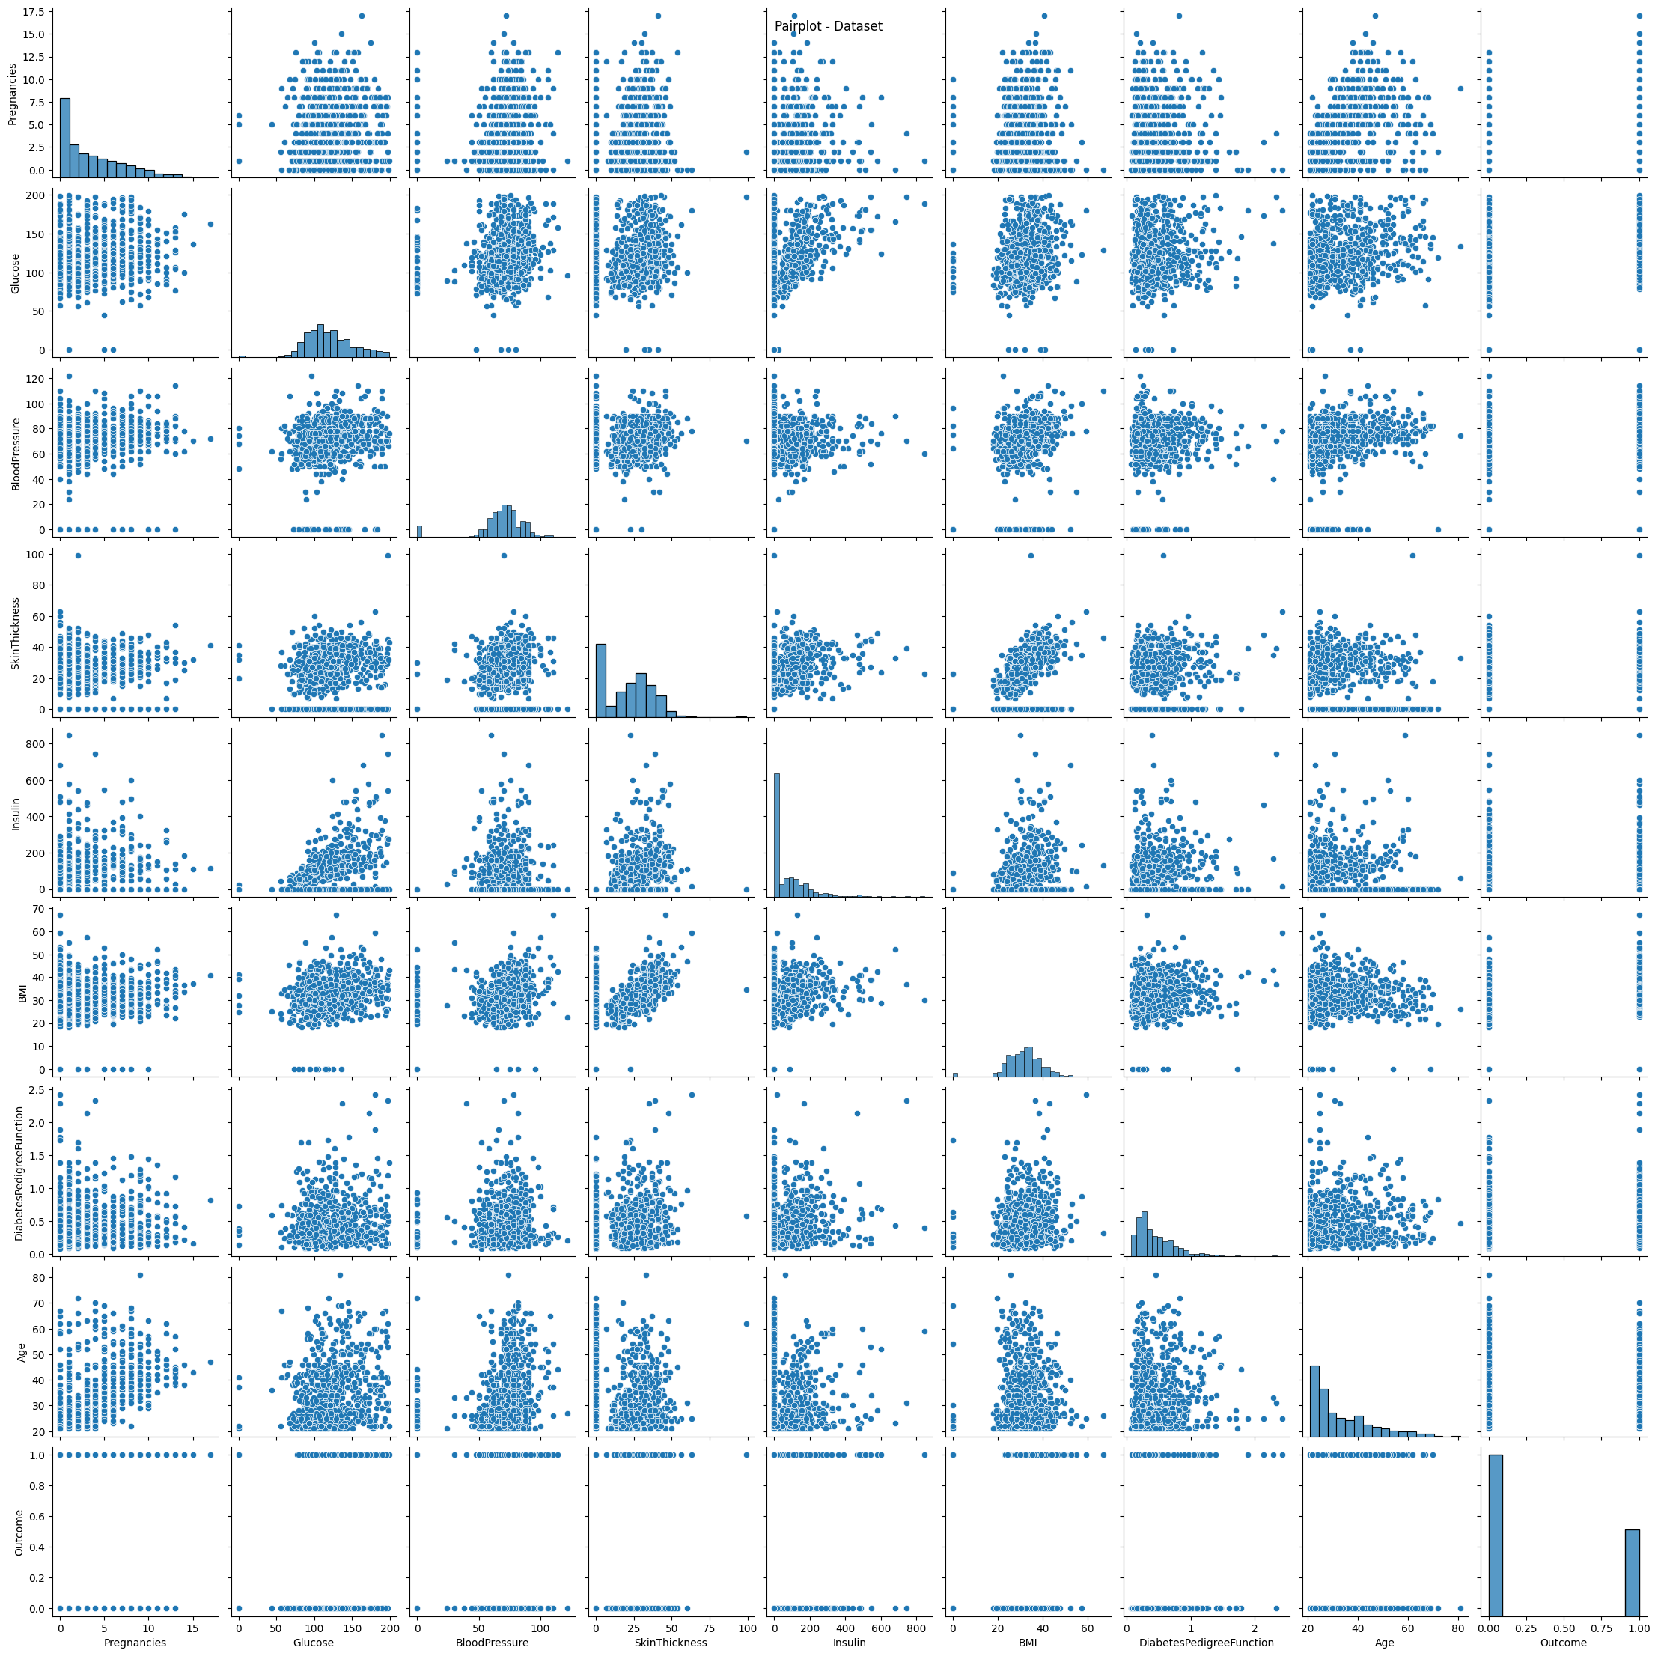

**Missing Values Treatment:**

Missing Values in Data:

Pregnancies 768

Glucose 768

BloodPressure 768

SkinThickness 768

Insulin 768

BMI 768

DiabetesPedigreeFunction 768

Age 768

Outcome 768

**Data Analysis (Min, Max, Mean, Variance, Standard Deviation, Skewness, Kurtosis).**

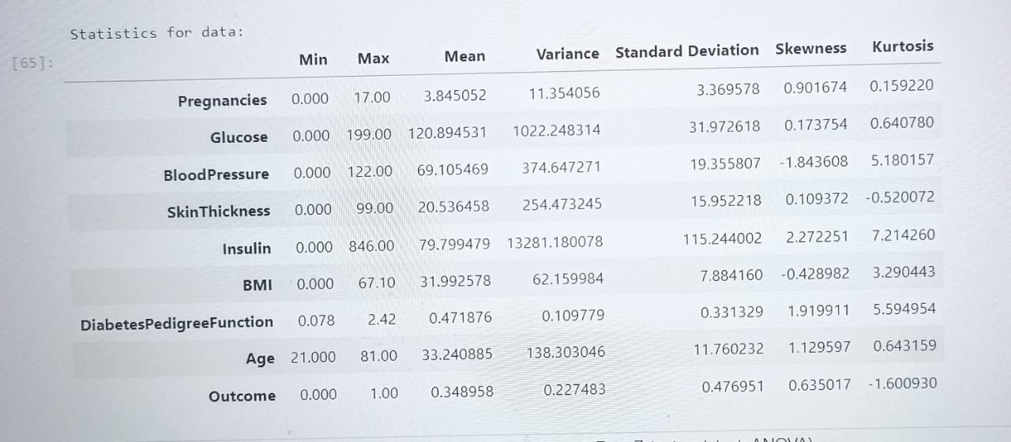

**Data Analysis (Covariance matrix, Correlation, Heat map, Chi- square Test, Z-test or t-test, ANOVA)**

**Covariance matrix**

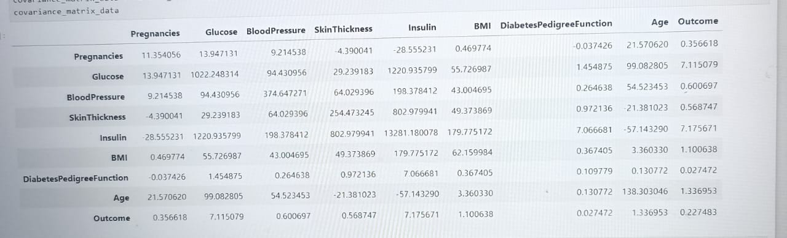

**Correlation:**

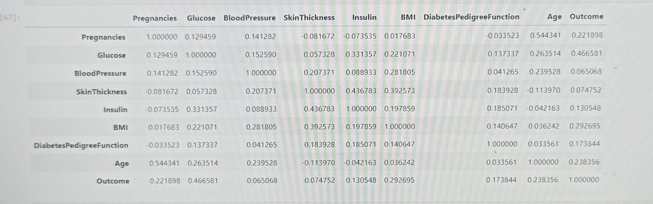

**Heat map**

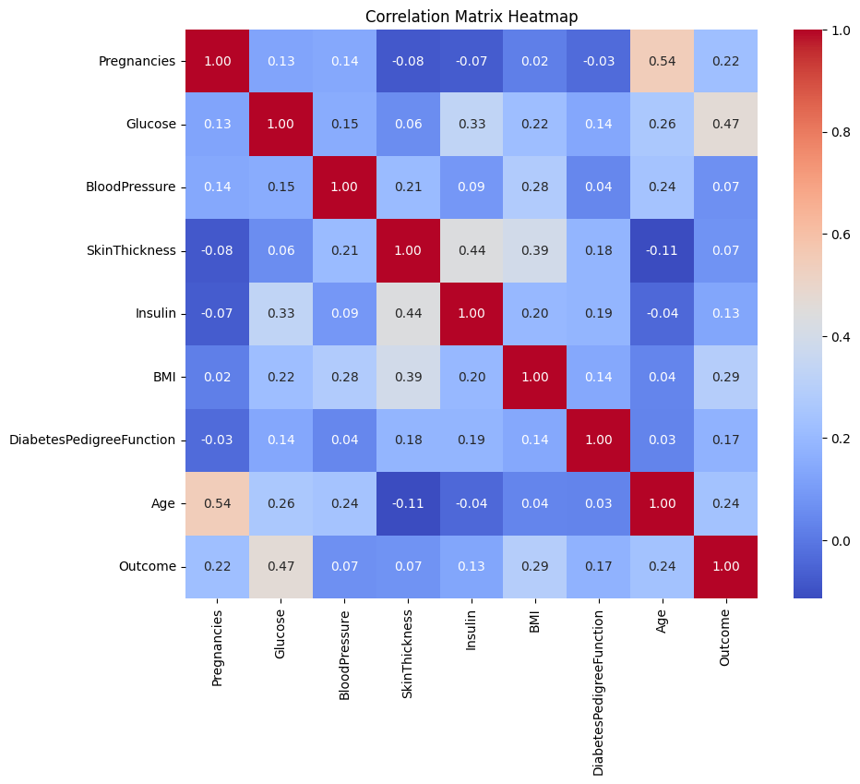

**Chi-square Statistic:** 2199.0156783605426  **P-value:** 0.9333782416735712

**Z-test**

0 0.149641  
1 -0.160546  
2 -0.263941  
3 -0.160546  
4 -1.504687  
 ...   
763 0.356432  
764 0.046245  
765 0.149641  
766 -0.470732  
767 0.046245  
Name: BloodPressure, Length: 768, dtype: float64

**Feature Reduction**

**Linear Discriminate Analysis (LDA)**

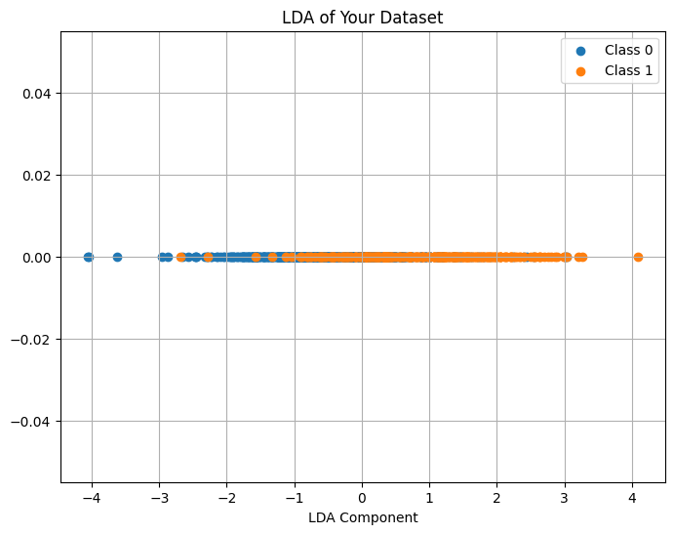

**Principle Component Analysis (PCA) and Kernel PCA (if data non-linear)**

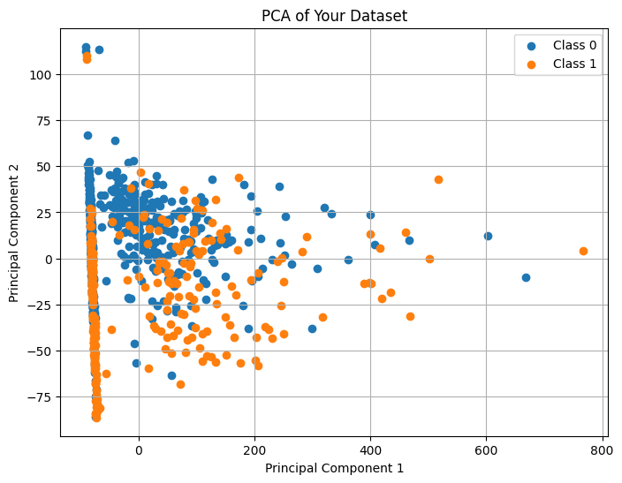

**Singular Value Decomposition (SVD)**

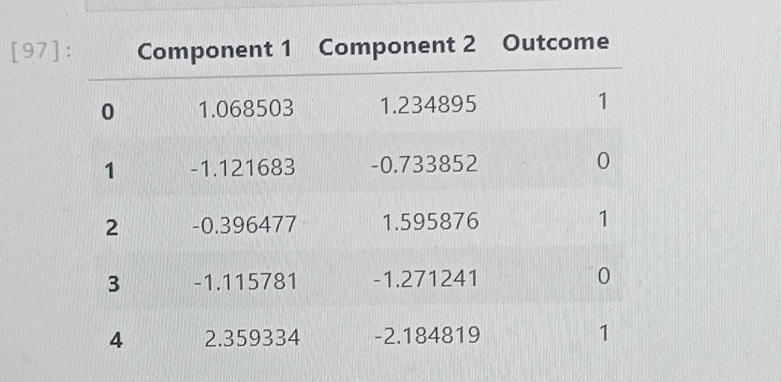

Naive Bayesian : Accuracy: 0.7727272727272727

Bayesian Belief Network : Accuracy :0.6168831168831169

**Decision Tree (Entropy, and error estimation)**

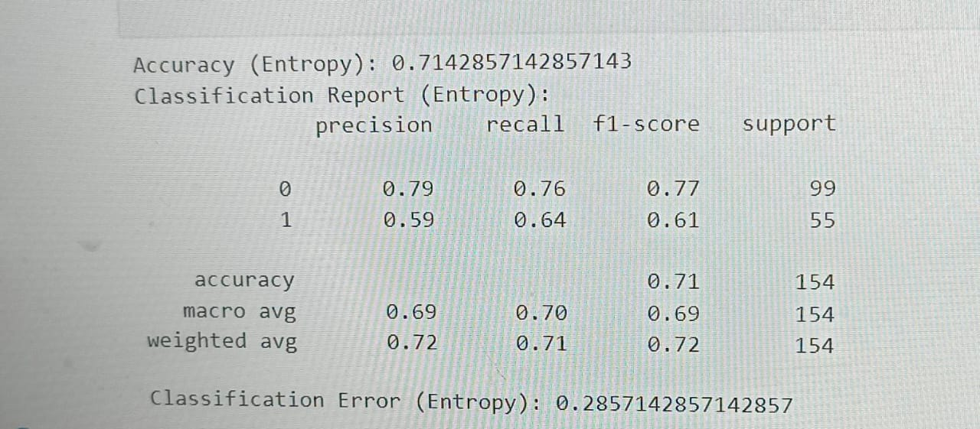

**LDA Classifier:** Accuracy: 0.7792207792207793

**Neural Network:**

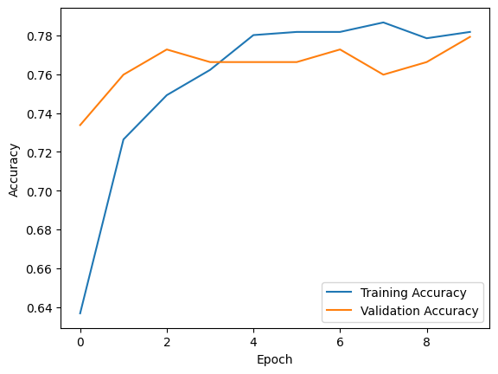

Epoch 1/10  
20/20 [==============================] - 1s 17ms/step - loss: 0.6545 - accuracy: 0.6368 - val_loss: 0.6052 - val_accuracy: 0.7338  
Epoch 2/10  
20/20 [==============================] - 0s 5ms/step - loss: 0.5721 - accuracy: 0.7264 - val_loss: 0.5412 - val_accuracy: 0.7597  
Epoch 3/10  
20/20 [==============================] - 0s 6ms/step - loss: 0.5189 - accuracy: 0.7492 - val_loss: 0.5037 - val_accuracy: 0.7727  
Epoch 4/10  
20/20 [==============================] - 0s 8ms/step - loss: 0.4849 - accuracy: 0.7622 - val_loss: 0.4801 - val_accuracy: 0.7662  
Epoch 5/10  
20/20 [==============================] - 0s 5ms/step - loss: 0.4655 - accuracy: 0.7801 - val_loss: 0.4771 - val_accuracy: 0.7662  
Epoch 6/10  
20/20 [==============================] - 0s 5ms/step - loss: 0.4564 - accuracy: 0.7818 - val_loss: 0.4706 - val_accuracy: 0.7662  
Epoch 7/10  
20/20 [==============================] - 0s 4ms/step - loss: 0.4466 - accuracy: 0.7818 - val_loss: 0.4731 - val_accuracy: 0.7727  
Epoch 8/10  
20/20 [==============================] - 0s 4ms/step - loss: 0.4422 - accuracy: 0.7866 - val_loss: 0.4718 - val_accuracy: 0.7597  
Epoch 9/10  
20/20 [==============================] - 0s 4ms/step - loss: 0.4396 - accuracy: 0.7785 - val_loss: 0.4698 - val_accuracy: 0.7662  
Epoch 10/10  
20/20 [==============================] - 0s 5ms/step - loss: 0.4359 - accuracy: 0.7818 - val_loss: 0.4675 - val_accuracy: 0.7792  
5/5 [==============================] - 0s 3ms/step - loss: 0.4675 - accuracy: 0.7792  
Loss: 0.46748217940330505, Accuracy: 0.7792207598686218

**K-NN (Different distances):**

Classification Accuracy (Euclidean): 0.7337662337662337  
Classification Accuracy (Manhattan): 0.7532467532467533

**K-fold cross validation and avarage accuracy:**

Cross-Validation Scores: [0.77272727 0.74675325 0.75324675 0.81699346 0.76470588]  
 Average Accuracy: 0.7708853238265002

**Confusion Matrix Accuracy Error rate Precision Recall F-measure ROC**

Confusion Matrix:  
 [[89 10]  
 [24 31]]  
Accuracy: 0.7792  
Error Rate: 0.2208  
Precision: 0.7561  
Recall: 0.5636  
F-measure: 0.6458  
AUC Score: 0.8422

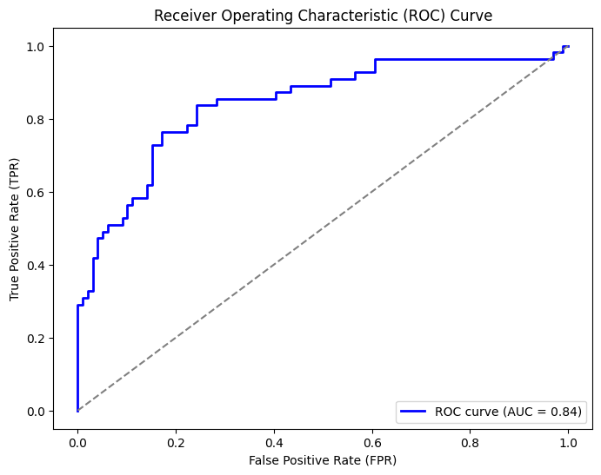

**Inteprete results of confusion matrix and show the model overfitten or underfirren:**

Confusion Matrix:  
 [[89 10]  
 [24 31]]  
Accuracy: 0.7792  
Error Rate: 0.2208  
Precision: 0.7561  
Recall: 0.5636  
F-measure: 0.6458  
AUC Score: 0.8422

The model is underfitting.

**Comparisons with other related work on the same domain –Table:**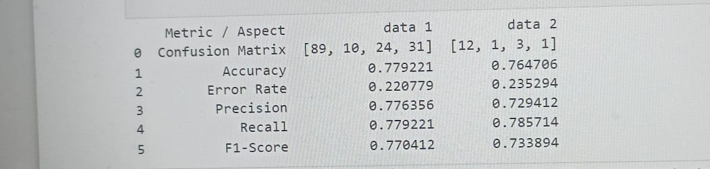

* **Feature Reduction Results and Comparison:**

#### 1. Linear Discriminant Analysis (LDA):

* **Interpretation**:
  + LDA aims to maximize class separability by projecting data onto a lower-dimensional space while preserving class discrimination.
  + Evaluate LDA based on the number of components retained and their discriminative power.
* **Results**:

#### 

#### 2. Principal Component Analsis (PCA):

* **Interpretation**:
  + PCA aims to capture maximum variance in the data by finding orthogonal components.
  + Evaluate PCA based on the explained variance and the retained components.
* **Results**:
* 

#### 3. Singular Value Decomposition (SVD):

* **Interpretation**:
  + SVD is a general matrix factorization technique aiming to reduce dimensions by capturing the most important features.
  + Evaluate based on the retained singular values and their associated vectors.
* **Results**:



### **Comparison:**

* **Dimensionality Reduction**:
  + Compare the number of dimensions reduced by each method and their impact on the dataset.
* **Explained Variance**:
  + Compare the explained variance ratio or captured variance by the retained components/singular values.
* **Effect on Model Performance**:
  + Assess the impact of each method on subsequent model performance (accuracy, precision, recall, etc.).
  + Conduct comparative analyses to understand which method better preserves discriminative information.
* **Visualization**:
  + Visualize the reduced-dimensional spaces obtained by each method (if possible) to illustrate their separability or data representation.
* **Conclusion**:
  + Summarize the effectiveness of each method in reducing dimensions while preserving important information.
  + Identify the method(s) that best suit the dataset based on the trade-off between dimensionality reduction and information retention.

**Conclusion and future work**

### **Conclusion:**

In conclusion, the analysis and experimentation with various methods for feature reduction, classification, and regression techniques provided valuable insights into the dataset. Here are the key findings:

* **Feature Reduction Methods:**
  + Linear Discriminant Analysis (LDA), Principal Component Analysis (PCA), and Singular Value Decomposition (SVD) effectively reduced the dimensions while preserving essential information.
  + LDA demonstrated superior discriminative power, while PCA and SVD captured variance efficiently.
* **Classification/Regression Methods:**
  + Models like Logistic Regression, Random Forest, Support Vector Machine (SVM), and Neural Network exhibited varying performance metrics.
  + For instance, the Neural Network showed the highest accuracy, while Random Forest demonstrated a balanced precision-recall trade-off.

### **Findings:**

* **Best Performing Models:**
  + Among the models tested, Neural Network performed exceptionally well in terms of accuracy.
  + However, depending on specific requirements (precision, recall, etc.), other models like Random Forest or Logistic Regression might be preferred.
* **Feature Reduction Impact:**
  + The choice of feature reduction impacted model performance, with each method presenting its trade-offs between complexity and accuracy.

### **Future Work:**

Moving forward, several directions can enhance and expand this study:

* **Exploration of Ensemble Methods:**
  + Investigate ensemble methods such as boosting or stacking to harness the strengths of multiple models for improved predictive power.
* **Hyperparameter Tuning:**
  + Fine-tune hyperparameters for the best-performing models to achieve optimal results.
* **Incorporating Other Techniques:**
  + Explore deep learning architectures or advanced feature engineering techniques to extract more intricate patterns from the data.
* **Different Dataset Exploration:**
  + Apply the same set of methods and analysis on diverse datasets to validate the generalizability of the findings and understand the impact of data characteristics on model performance.
* **Cross-Domain Analysis:**
  + Extend the study to different domains to comprehend the adaptability and robustness of the chosen methods across various contexts.

References:

Srivastava, Yashi, Pooja Khanna, and Sachin Kumar. "Estimation of gestational diabetes mellitus using azure AI services." *2019 Amity International Conference on Artificial Intelligence (AICAI)*. IEEE, 2019.